Elora Family Physician FHO Opportunity
Centre Wellington (Fergus/Elora) Central/West Ontario

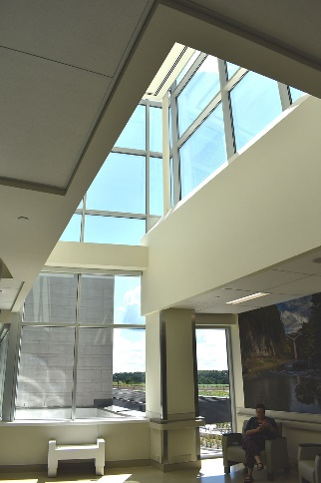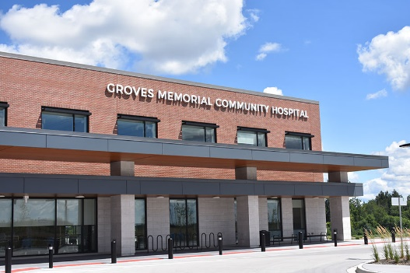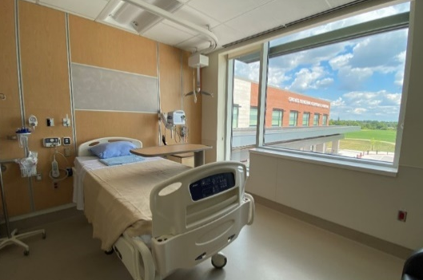

Family Physician Upper Grand FHO opportunity available in turn-key Elora group practice.

We are looking for a physician interested in working:
- in a collegial Family Health Organization environment
- in the hospital under an AFA for 24-hour emergency care
- to support primary care, as well as the local hospital through inpatient, emergency, oncology, and/or obstetrical care
- established 1,300 patient roster that can be taken as a whole or fractioned

We offer:
- mentorship available for new graduates looking to transition into practice
- high income potential
- teaching opportunities with McMaster University or ROMP learners
- support from Family Health Team programs targeted toward diabetes, cardiac, respiratory, mental health and arthritis care issues, healthy lifestyle coaching and women’s health issues
- on-site Specialist support at the hospital and via OTN
- FHO physician office is located in Elora, Ontario and is shared with three other family physicians

The Upper Grand FHO currently consists of 31 physicians providing office and inpatient care. Many of the team also provide care to LTC patients and support the newly opened Groves Memorial Community Hospital (GMCH) ER and OB/delivery. ER shifts are 24 hours or can be split to 12 hour shifts if preferred and remunerated via an AFA. OB on-call is also available with remuneration via HOCC. There are opportunities to work in ER, long-term care, as well as surgical assist.

GMCH is a 44-bed acute care facility (with the ability to surge to 50 beds) has two state-of-the-art operating rooms, three labour and delivery rooms (approx. 500 deliveries/year), CT scanner and 24-7 emergency department. We have onsite social work, physio, SLP, RT, HCC, a geriatrics emergency management (GEM) team, general surgery, internal medicine, OBGYN, and supportive nurses.

GMCH is actively involved in training family medicine residents and medical students. Hospital On-call stipend is available. Office space available within the hospital.

Please check us out at: www.gmch.ca and www.whcrecruit.com or email Alison Armstrong at aarmstrong@whca.ca

